**Experiment Tracking and Model Management**

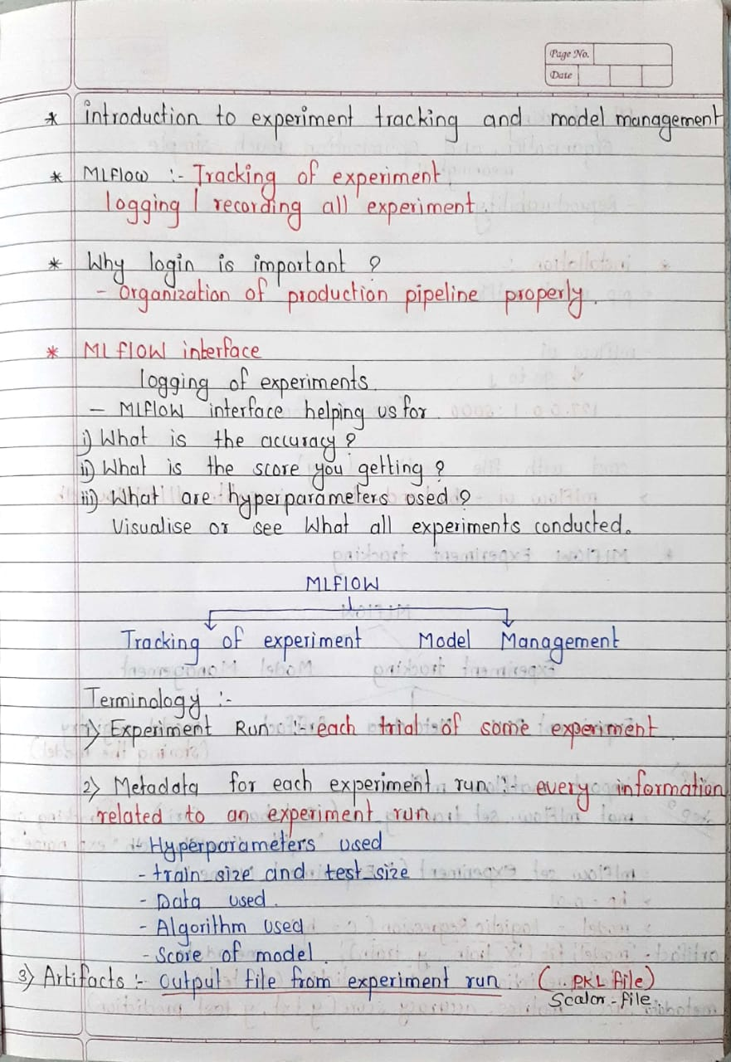

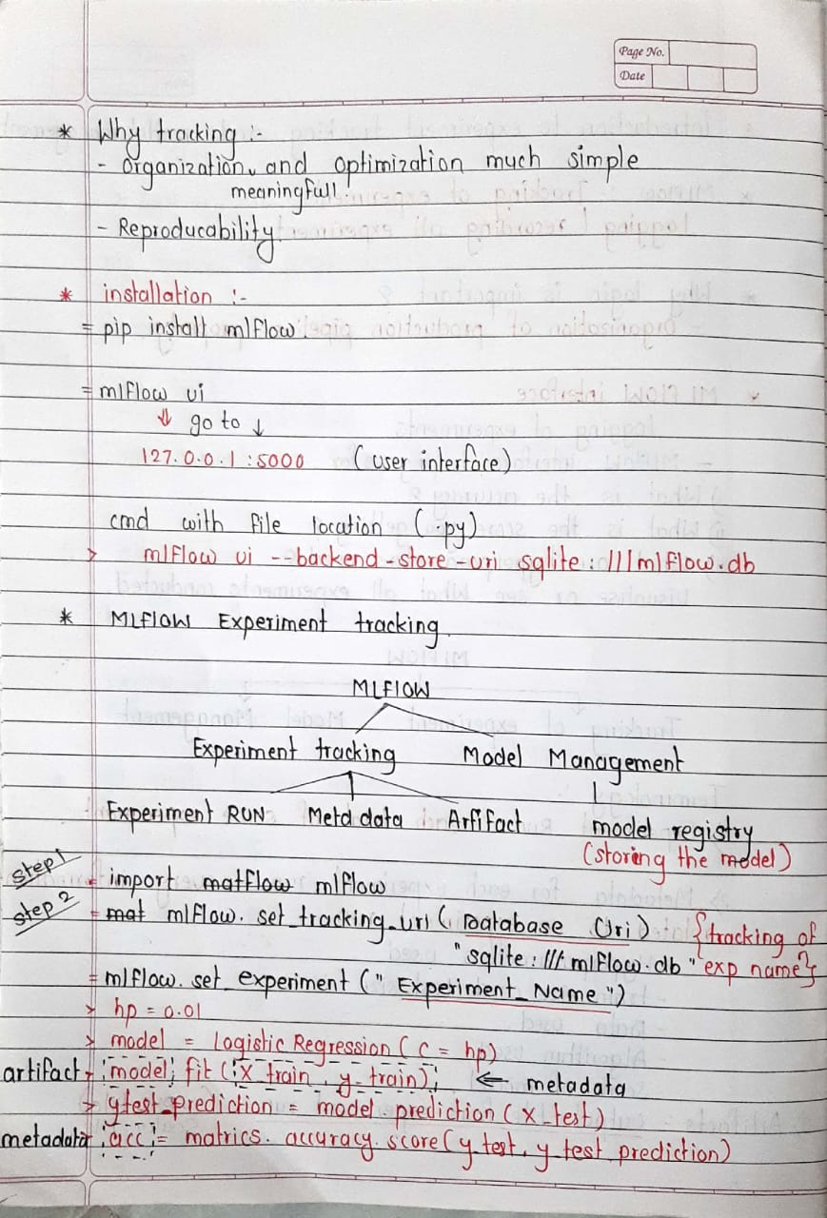

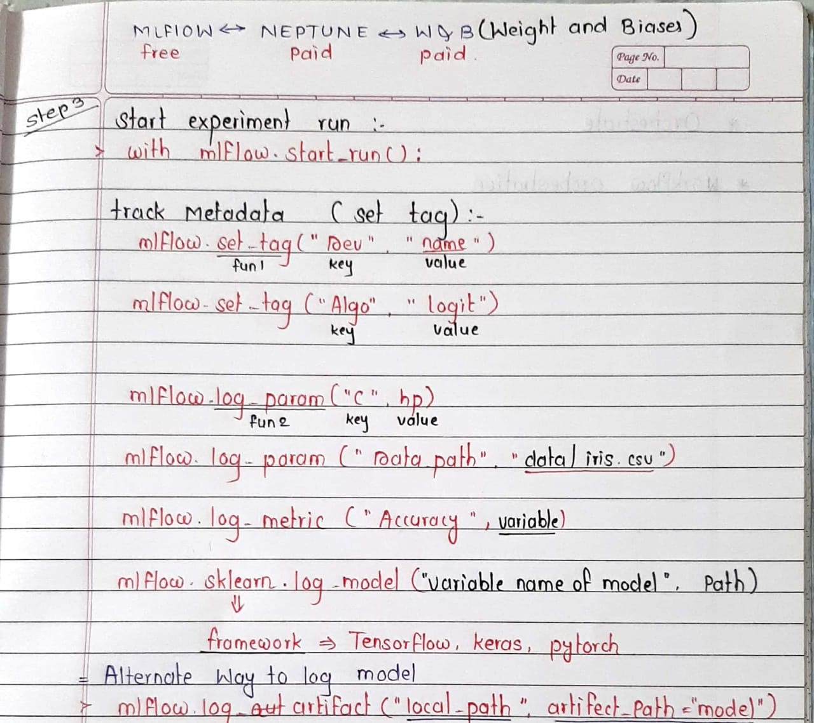

# ****Step 1 - Import MLFlow****

# import mlflow

# ****Step 2 - Set the tracker and experiment****

# mlflow.set_tracking_uri(DATABASE_URI) mlflow.set_experiment("EXPERIMENT_NAME")

# ****Step 3 - Start a experiment run****

# with mlflow.start_run():

# ****Step 4 - Logging the metadata****

# mlflow.set_tag(KEY, VALUE) mlflow.log_param(KEY, VALUE) mlflow.log_metric(KEY, VALUE)

# **Step 5 - Logging the model and other files (2 ways)**

# **Way 1 -** mlflow.<FRAMEWORK>.log_model(MODEL_OBJECT, artifact_path="PATH") **Way 2 -** mlflow.log_artifact(LOCAL_PATH, artifact_path="PATH")

## MLFlow Interface for Tracking Experiments

# 

# 

## MLFlow Interface for Model Management

